**IMAGE PROCESSING AND AUTOMATED DIAGNOSIS OF MULTIPLE SCLEROSIS IN BRAIN MRI USING U-NET**

**PROJECT-21ECP302L**

***Submitted by* GOKULSIVARAJ [Reg No:RA2211004010574]**

**IBRAHIM MOHAMED [Reg No: RA2211004010585]**

**HARAVINDA KRISHNA [Reg No: RA2211004010600]**

*Under the guidance of*

**Dr. KALIMUTHU K**(Associate Professor, Department of Electronics & Communication Engineering)

**BACHELOR OF TECHNOLOGY**in

**ELECTRONICS & COMMUNICATION ENGINEERING  
DEPARTMENT OF ELECTRONICS AND COMMUNICATION ENGINEERING**

**COLLEGE OF ENGINEERING AND TECHNOLOGY**

**SRM INSTITUTION OF SCIENCE AND TECHNOLOGY**

**KATTANKULATHUR – 603 203**

**MAY 2025**

**SRM INSTITUTE OF SCIENCE AND TECHNOLOGY**

(Under Section 3 of UGC Act,1956)

**DEPARTMENT OF ELECTRONICS AND COMMUNICATION**

**ENGINEERING**

**BONAFIDE CERTIFICATE**

Certified that this project report titled “**IMAGE PROCESSING AND AUTOMATED DIAGNOSIS OF MULTIPLE SCLEROSIS IN BRAIN MRI USING U-NET**” is the bonafide work of **GOKULSIVARAJ [RA2211004010574], IBRAHIM MOHAMED [RA2211004010585],** and **HARAVIND KRISHNA [RA2211004010600],** who carried out the project work under my supervision as part of the course **21ECP302L - PROJECT.**

Certified further that, to the best of my knowledge, the work reported herein is original and was carried out during the academic year 2024–2025 (Even) at **SRM Institute of Science and Technology, Kattankulathur.**



ABSTRACT

Multiple Sclerosis (MS) is a chronic neurological disorder characterized by the formation of lesions in the brain and spinal cord. Accurate and early detection of these lesions is critical for effective diagnosis, disease monitoring, and treatment planning. This project proposes an automated approach for the segmentation and detection of MS lesions from brain MRI scans using a deep learning model based on the U-Net architecture. The model is trained on a dataset of 2D FLAIR MRI slices, paired with manually annotated binary lesion masks. Preprocessing steps, including normalization and noise reduction, are applied to enhance lesion visibility. The U-Net model is trained with a combination of binary cross-entropy and Dice loss to address class imbalance. Evaluation metrics such as F1-score, precision-recall curves, ROC curves, and confusion matrices are used to assess the performance of the trained model.

The system achieves a training accuracy, indicating effective generalization to unseen data. Despite achieving high test accuracy, the model yields a relatively low F1-score, highlighting the challenge of segmenting small or sparse lesions. The project concludes with a discussion on potential improvements, including advanced loss functions, increased training data, and enhanced augmentation techniques, to boost lesion-level sensitivity and clinical reliability.

**TABLE OF CONTENTS**



ABSTRACT iii

TABLE OF CONTENTS iv

LIST OF FIGURES vi

TABLE OF CONTENT vii

LIST OF ABBREVIATIONS viii

CHAPTER 1 INTRODUCTION 1

1.1. Introduction 1

1.2. Objective 2

1.3. Role of MRI in MS lesions 2

1.4. U-Net Architecture 3

CHAPTER 2 LITERATURE SURVEY 5

2.1. CNN – Based Approches for MS Detection 5

2.2. Deep Learning for Lesion Segmentation and Classification 6

2.3. Multiple – Modal MRI and Hybrid Techniques 6

2.4. Clinical Relevance and Diagnostic Impact 7

CHAPTER 3 SOFTWARE DESCRIPTION 8

3.1. Python 8

3.2. Google collab 8

3.3. TensorFlow / keras 8

3.4. Numpy 8

3.5. OpenCV 9

3.6. Matplotlib and Seaborn 9

3.7. Scikit-learn (sklearn) 9

CHAPTER 4 METHODOLOGY 10

4.1. System Model 10

4.2. Overview of System model 11

4.2.1. MS Dataset Acquistion 11

4.2.2. Pre-Processing 11

4.2.3. Data Partitioning 11

4.2.4. Set Hyperparameter & Build CNN Architecture 12

4.2.5. Network Training 12

4.2.6. Diagnosis Output 12

4.2.7. Performance Compuation 12

4.3. Dataset Collection and Preparation 13

4.4. Image Pre-Processing 13

4.5. Data Partitioning 13

4.6. U-Net Architecture 14

4.7. Hyperparameter Tuning 14

4.8. Model Training 14

4.9. Model Evaluation 15

4.10. Output and Visualization 15

CHAPTER 5 RESULTS AND DISCUSSION 16

5.1. Result 16

5.1.1. Original Images 17

5.1.2. Bounding Box 18

5.1.3. Prediction Mask 19

5.1.4. Confusion Matrix 21

5.1.5. ROC Analysis 22

5.1.6. Visualization 23

CHAPTER 6 CONCLUSION AND FUTURE WORK 25

6.1. Conclusion 25

6.2. Future work 25

6.3. Realistic Constraints 26

REFRENCES 27

LIST OF FIGURES

4.1 System Model of Image Processing and Automated Diagnosis of Multiple Sclerosis in Brain MRI using U-Net 10

5.1 Raw data of FLAIR MRI Image with MS Lesions 1 17

5.2 Raw data of FLAIR MRI Image with MS Lesions 2 17

5.3 Raw data of FLAIR MRI Image with MS Lesions 3 18

5.4 FLAIR MRI Image with Bounding box of MS Lesions 1 18

5.5 FLAIR MRI Image with Bounding box of MS Lesions 2 19

5.6 FLAIR MRI Image with Bounding box of MS Lesions 3 19

5.7 FLAIR MRI Image with Binary mark and of MS Lesions 1 20

5.8 FLAIR MRI Image with Binary mark and of MS Lesions 2 20

5.9 FLAIR MRI Image with Binary mark and of MS Lesions 3 21

5.10 Confusion Matrix of Processed MS lesions MRI image 22

5.11 ROC Curve of Processed MS lesions MRI image 22

5.12 Original images and U-Net layer-1 for MRI Images 23

5.13 U-Net layer-2 and layer-3 for MRI Images 23

5.14 U-Net layer-4 and layer-5 for MRI Images 24

5.15 Prediction of U-Net Architecture for MRI Images 24

LIST OF TABLES



5.1 Stimulation parameters for MS Lesions Detection using U-Net 16

LIST OF ABBREVIATIONS

|  |  |
| --- | --- |
| **MS** | Multiple Sclerosis |
| **MRI** | Magnetic Resonance Imaging |
| **FLAIR** | Fluid Attenuated Inversion Recovery |
| **CNN** | Convolutional Neural Networks |
| **U-Net** | U – Network (Convolutional Neural Networks) |
| **2D** | 2 Dimensional |
| **ROC** | Receiver Operating Characteristic |
| **CNS** | Central Nervous System |
| **CSF** | Cerebra Spinal Fluid |
| **CLI** | Command Line Interface |
| **CNN** | Convolutional Neural Networks |
| **GPU** | Graphics Processing Unit |
| **TPU** | Tensor Processing Unit |
| **APU** | Application Programming Interface |
| **Open-CV** | Open Source Computer Vision Library |
| **ROI** | Regions of Interest |
| **TP** | **True Positives** |
| **TN** | True Negatives |
| **FP** | False Positives |
| **FN** | False Negative |
| **AUC** | Area Under the(ROC) Curve |
| **DNN** | Deep Neural Network |
| **AI** | Artificial Intelligence |

CHAPTER 1  
INTRODUCTION

1. Introduction

Multiple Sclerosis (MS) is a chronic autoimmune disease that affects the central nervous system, particularly the brain and spinal cord. It is characterized by the formation of demyelinating lesions, which result from the immune system attacking the protective myelin sheath surrounding nerve fibers. These lesions can lead to a wide range of neurological symptoms, including muscle weakness, vision problems, cognitive impairment, and loss of coordination. Magnetic Resonance Imaging (MRI), especially FLAIR (Fluid Attenuated Inversion Recovery) sequences, is the most effective non-invasive imaging modality for identifying MS lesions due to its high contrast for white matter abnormalities.

Manual identification and segmentation of MS lesions from MRI scans by radiologists is a labor-intensive and time-consuming task, often prone to human error and variability. Small lesion sizes, complex brain structures, and overlapping intensities between lesions and healthy tissue further complicate this process. As a result, there is a pressing need for automated and accurate methods to detect and segment MS lesions, which can aid neurologists in diagnosis, monitoring disease progression, and evaluating treatment response more efficiently.

Deep learning, particularly Convolutional Neural Networks (CNNs), has revolutionized the field of medical image analysis by enabling automatic feature extraction and pattern recognition. Among various CNN architectures, the U-Net model has emerged as a powerful tool for image segmentation tasks. Its encoder-decoder structure with skip connections enables precise localization and pixel-wise classification, making it suitable for detecting small and sparse regions such as MS lesions in MRI scans. The use of U-Net helps overcome challenges related to class imbalance and small lesion size by preserving spatial information during upsampling.

In this project, we develop and train a U-Net-based model for the segmentation of MS lesions from 2D FLAIR MRI slices. The dataset consists of preprocessed MRI images and corresponding binary lesion masks. The model is trained and validated using various performance metrics such as accuracy, F1-score, precision-recall curves, ROC curves, and confusion matrices. Although the model achieves high testing accuracy, it exhibits a relatively low F1-score due to class imbalance and lesion complexity. The project also explores ways to enhance model performance and discusses the implications of automated MS lesion detection in clinical practice.

1. Objective

* The primary objective of this project is to develop an automated, accurate, and efficient deep learning model based on the U-Net architecture for detecting and segmenting MS lesions in brain MRI scans, specifically FLAIR sequences. By leveraging the encoder-decoder structure of U-Net, the model aims to perform pixel-wise classification of lesions, capturing both local and global contextual features essential for distinguishing small and irregularly shaped lesion areas from healthy tissue.
* This system is intended to reduce the manual workload of radiologists, enhance diagnostic consistency, and support timely monitoring of disease progression. To achieve this, the project focuses on pre-processing MRI images, generating corresponding binary lesion masks, training the model with appropriate hyperparameters, and evaluating its performance using robust metrics.

1. Role of MRI in MS lesions

MS is a chronic autoimmune neurological disorder characterized by demyelination in the central nervous system (CNS). One of the critical challenges in diagnosing and monitoring MS is the accurate detection and evaluation of lesions that form in the brain and spinal cord. These lesions are indicative of disease activity and progression, making their identification crucial for early diagnosis, treatment planning, and prognosis.

MRI plays a pivotal role in the clinical management of MS due to its non-invasive nature and high spatial resolution. It enables visualization of brain tissue in detail, facilitating the detection of even small lesions in white matter regions. Among various MRI modalities, FLAIR is especially effective in suppressing cerebrospinal fluid (CSF) signals, thereby enhancing the visibility of MS lesions near the ventricles and cortical surfaces.

MRI not only assists in the initial diagnosis of MS by identifying the number, location, and pattern of lesions but also supports longitudinal studies that monitor changes in lesion load over time. This capability is essential in assessing treatment efficacy and disease progression. Moreover, the McDonald criteria, widely used for MS diagnosis, rely heavily on MRI findings to demonstrate dissemination of lesions in time and space.

Advances in image processing, including machine learning and deep learning, have further enhanced the utility of MRI in MS. Automated segmentation techniques, particularly those using CNNs like U-Net, are now being developed to detect and quantify MS lesions with greater accuracy and consistency, reducing reliance on manual annotation. These innovations promise to make MRI a more powerful tool for precision medicine in MS care.

1. U-Net Architecture

**U-Net** CNN architecture specifically designed for image segmentation tasks, particularly in the biomedical domain. Developed by Olaf Ronneberger and colleagues in 2015, U-Net has a distinctive U-shaped architecture consisting of a contracting path (encoder) and an expansive path (decoder). The encoder captures the context of the input image through a series of convolution and pooling operations, while the decoder enables precise localization by performing up-sampling and combining feature maps from the encoder through skip connections. These skip connections are particularly crucial in retaining spatial information that is often lost during the down-sampling process in traditional CNNs.

In the context of this project, which focuses on detecting MS lesions in brain MRI images, U-Net plays a pivotal role. MS lesions are often small, scattered, and have low contrast in MRI scans, making manual detection both difficult and time-consuming. U-Net, with its ability to handle limited data and provide pixel-level accuracy, is ideally suited for this task. The model is trained on preprocessed FLAIR MRI slices paired with corresponding binary lesion masks. These masks help the network learn to differentiate between lesion and non-lesion areas based on spatial and intensity features in the images.

The trained U-Net model is then used to predict lesion masks on unseen test images, producing a binary segmentation output that highlights areas suspected of containing MS lesions. The performance of the model is evaluated using metrics such as the F1 score, precision-recall curve, ROC curve, and confusion matrix. These metrics assess how accurately the model can detect true lesions while minimizing false positives and negatives.

Overall, the integration of the U-Net architecture in this project significantly enhances the efficiency and accuracy of MS lesion detection in MRI scans. It offers a powerful automated tool for medical professionals, potentially improving early diagnosis, monitoring disease progression, and evaluating treatment effectiveness in patients with Multiple Sclerosis.

CHAPTER 2  
LITERATURE SURVEY

MS is a chronic neurological disease affecting the central nervous system, diagnosed primarily through MRI imaging. Recent advancements in image processing and deep learning, especially CNNs, have shown promise in improving the diagnosis and segmentation of MS lesions from brain MRI. This section explores major contributions and developments in the field, focusing on CNN-based approaches and image processing techniques.

### **CNN-Based Approaches for MS Detection**

CNNs have revolutionized medical imaging by enabling automated feature extraction and classification with minimal human intervention. In the context of MS, CNNs have been applied to identify and classify MS lesions in brain MRI scans with promising results. Maleki et al. [11] presented an early implementation of CNNs for diagnosing MS using MRIs, demonstrating that deep learning could extract meaningful spatial patterns correlated with MS pathology. Building on this, Soltani and Nasri [12] proposed an improved CNN algorithm that significantly enhanced diagnostic accuracy through fine-tuning of network layers and preprocessing techniques, such as intensity normalization and skull stripping. These studies collectively highlight that CNNs offer robust performance when trained with properly preprocessed datasets and optimized architectures.

Furthermore, Sah and Dikeroglu [13] surveyed a range of deep learning models used in MS diagnosis, with a strong emphasis on CNNs. Their findings reveal that CNNs, when properly designed, consistently outperform traditional image processing and machine learning methods in identifying MS lesions. They particularly noted the CNN’s capacity to adapt to diverse imaging conditions and lesion appearances, which is crucial given the variability in MRI scans across different patients and scanners. The review also stressed the importance of large annotated datasets for training, which remains a challenge in medical imaging. Nevertheless, the potential of CNN-based architectures to evolve into clinically deployable tools is evident from their growing accuracy and reliability.

### **Deep Learning for Lesion Segmentation and Classification**

Accurate segmentation of MS lesions in MRI is essential for disease diagnosis, progression monitoring, and treatment planning. Deep learning, especially CNNs integrated with segmentation architectures like U-Net, has proven effective for this task. Akselrod-Ballin et al. [9] developed an advanced method that uses multichannel MRI input (such as T1, T2, and FLAIR sequences) to segment and classify MS lesions automatically. Their approach showed high accuracy by leveraging the complementary information from various MRI modalities. Similarly, Biotta et al. [14] incorporated evolutionary computation into a CNN-based framework, which provided an intelligent way of optimizing the lesion segmentation process. These techniques mark a shift toward highly automated pipelines that require minimal manual input, making them scalable for clinical use.

In addition, Nabizadeh et al. [15] conducted a systematic review highlighting the role of AI, particularly CNNs, in improving lesion segmentation and classification. They found that CNN-based methods consistently outperformed traditional algorithms in sensitivity and specificity. The review also noted the adoption of hybrid models combining CNNs with decision trees or ensemble learners to refine predictions. Importantly, the integration of automated segmentation tools into clinical workflows is beginning to address the limitations of manual radiologist-driven lesion detection, such as subjectivity and variability. These deep learning models are not only fast but can be trained to adapt to patient-specific imaging characteristics, further improving their practical utility.

1. **Multi-Modal MRI and Hybrid Techniques**

Multi-modal MRI imaging is crucial for comprehensive MS diagnosis as it captures diverse tissue contrasts, allowing lesions to be distinguished more clearly. CNNs trained on multimodal datasets benefit from the rich spatial and contrast information embedded in sequences like T1, T2, FLAIR, and T1-post contrast. Ma et al. [8] employed such an approach, integrating various modalities into their CNN-based pipeline for MS lesion analysis. Their method demonstrated enhanced diagnostic performance, especially in identifying smaller lesions that are often missed in single-sequence imaging. The use of multimodal data enables the CNN to learn complex relationships between different tissue appearances, leading to improved sensitivity in lesion detection.

Similarly, Kermi et al. [3] explored a U-Net-based model for brain tumor and MS lesion segmentation using multimodal MRI volumes. Their study highlighted the advantages of feature fusion from different MRI types, which improved the robustness and generalizability of the model across various patient datasets. The hybrid use of U-Net within CNN frameworks also helped in better delineation of lesion boundaries, a critical factor in accurate volume estimation. These multimodal and hybrid approaches are now becoming standard practice in deep learning-based neuroimaging research, showcasing their ability to capture nuanced lesion characteristics that are essential for effective MS diagnosis and management.

* 1. **Clinical Relevance and Diagnostic Impact**

For CNN-based diagnostic systems to be adopted in healthcare, they must align with clinical guidelines and reduce common diagnostic errors. Solomon et al. [4], [5], and [6] have provided a foundational understanding of how MS is often misdiagnosed due to overlapping symptoms with other neurological conditions. Their work emphasized the need for objective, imaging-based tools to support clinical decision-making. The integration of CNNs into MRI interpretation can significantly reduce subjectivity by providing consistent and reproducible results. This shift toward automated interpretation is particularly valuable in resource-limited settings or in centers with fewer trained radiologists.

**CHAPTER 3  
SOFTWARE DESCRIPTION**

1. **Python**

Python is the primary programming language used in this project. It is widely adopted in machine learning and medical imaging due to its simplicity, vast library ecosystem, and community support. Python facilitates the development of deep learning models, image processing routines, and evaluation scripts.

1. **Google Colab**

Google Colab is a cloud-based Jupyter notebook environment that allows users to write and execute Python code in the browser with free access to (Graphics processing unit) GPUs and (Tensor processing unit) TPUs. It is ideal for deep learning tasks as it provides a pre-configured environment and easy integration with Google Drive for dataset handling.

1. **TensorFlow/Keras**

TensorFlow is an open-source deep learning framework developed by Google. Keras is its high-level API(Application Programming Interface) used to quickly design and train deep neural networks. In this project, Keras is used to define and train the U-Net architecture, which is specifically designed for biomedical image segmentation.

1. **NumPy**

NumPy is a powerful library for numerical computing in Python. It is used in this project for efficient array operations, reshaping image tensors, and performing mathematical computations during data preprocessing and evaluation.

1. **OpenCV(cv2)**

OpenCV (Open Source Computer Vision Library) is used for image processing tasks such as resizing, reading, and manipulating MRI images and masks. It supports various image formats and is optimized for performance.

1. **Matplotlib and Seaborn**

Matplotlib is a plotting library used to visualize model performance, including training/validation loss curves, prediction outputs, and comparison between original and segmented images.

1. **Scikit-learn (sklearn)**

Scikit-learn is a machine learning library used in this project for calculating evaluation metrics like F1 score, precision, recall, ROC curve, and generating the confusion matrix. It provides robust tools for model assessment and analysis.

CHAPTER 4  
METHODOLOGY

This work proposes a deep learning method for automated MS diagnosis using only FLAIR MRI images, known for clearly highlighting lesions. The pipeline includes skull stripping, bias correction, denoising, and intensity normalization. Preprocessed images are fed into a CNN to detect lesion patterns. Using only FLAIR simplifies data needs while preserving diagnostic value. This approach offers a scalable and efficient solution for MS detection.

* 1. 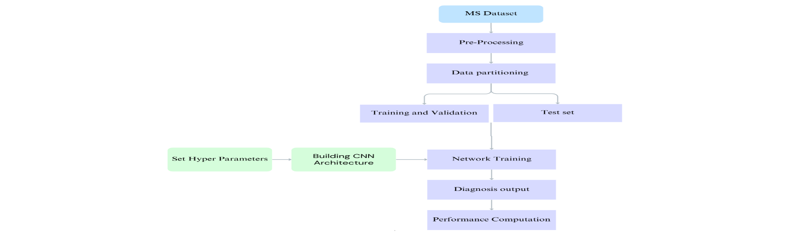System Model

**Fig 4. 1 : System Model of Image Processing and Automated Diagnosis of Multiple Sclerosis in Brain MRI using U-Net**

* 1. Overview of System Model

In Fig. 4.1, the work flow diagram comprises the following key components:

1. **MS Dataset Acquisition:**

The project begins with the acquisition of a dedicated MRI dataset containing brain scans of individuals diagnosed with MS. This dataset forms the foundation for training and evaluating the model. The images typically include T1, T2, or FLAIR modalities, which highlight MS lesions more clearly. The availability of labeled data, particularly ground truth lesion masks, is crucial for training a supervised deep learning model such as U-Net.

1. **Pre-Processing:**

Once the dataset is collected, pre-processing is performed to ensure the images are suitable for input into the convolutional neural network. Pre-processing may include resizing the images to a consistent dimension, normalizing pixel intensities, and applying filters to enhance image quality. Additionally, any unnecessary noise is removed, and in some cases, skull stripping and bias field correction are performed. Data augmentation techniques may also be used to artificially increase the size and diversity of the dataset, improving the model's generalization.

1. **Data Partitioning:**

After pre-processing, the dataset is divided into three subsets: training, validation, and testing. The training and validation sets are used during the model development phase, where the model learns patterns in the data and adjusts its parameters. The test set, on the other hand, is kept separate and used only after training is complete to evaluate the model's performance on unseen data. This partitioning helps ensure that the model's evaluation is unbiased and realistic.

1. **Set Hyperparameters & Build CNN Architecture:**

With the data ready, the next step is to define and tune key hyperparameters such as the learning rate, number of epochs, batch size, and optimizer. These settings control how the model learns. The U-Net CNN architecture is then constructed. U-Net is specifically designed for biomedical image segmentation and includes contracting and expanding paths that help the model capture both local and global features effectively. This architecture is well-suited for segmenting lesions in MRI scans.

1. **Network Training:**

The CNN model is trained using the training dataset while its performance is monitored on the validation set. During training, the model iteratively updates its weights to minimize the loss function, which measures the difference between predicted outputs and the ground truth labels. Proper training ensures the network learns to detect lesion patterns accurately, while regular validation prevents overfitting.

1. **Diagnosis Output:**

After training, the model is applied to the test set to generate predictions. These predictions are essentially segmented images where lesions are highlighted, acting as a diagnostic aid. The results help in identifying the presence and extent of MS lesions in the MRI scans, providing valuable insights for clinical decision-making.

1. **Performance Computation:**

Finally, the model’s output is quantitatively assessed using various performance metrics. These include the F1 score, which balances precision and recall; the precision-recall curve, which shows the trade-off between true positives and false positives; the ROC curve, which evaluates the sensitivity and specificity of the model; and the confusion matrix, which gives a detailed breakdown of prediction accuracy. These metrics help determine how well the model is performing and where it can be improved.

The project follows a structured deep learning pipeline aimed at detecting and segmenting MS lesions from brain MRI scans using a CNN-based U-Net architecture. The entire methodology can be divided into several key stages

* 1. **Dataset Collection and Preparation**

The first step involves acquiring a dataset of brain MRI scans annotated with MS lesions. These images typically include FLAIR sequences due to their high sensitivity in highlighting MS plaques. Each image in the dataset is associated with a ground truth mask indicating lesion regions. The dataset is pre-analysed for completeness and image quality before further processing.

* 1. **Image Pre-processing**

Pre-processing is essential to ensure uniformity and enhance the quality of the input data. This includes:

* **Resizing** all images to a fixed dimension (e.g., 256x256 or 512x512 pixels) for network compatibility.
* **Normalization** of pixel intensity values to a [0,1] range to stabilize the training.
* **Noise removal**, contrast enhancement, and histogram equalization where required.
* **Data augmentation** (e.g., rotations, flips, zooms) to artificially increase the dataset size and improve the model's ability to generalize to new data.
  1. **Data Partitioning**

The dataset is split into three subsets:

* **Training Set** (80%) for learning features.
* **Validation Set** (~10–15%) for tuning hyperparameters and preventing overfitting.
* **Test Set** (~10–15%) for final unbiased performance evaluation.  
  This partitioning ensures robust model training and fair evaluation.
  1. **U-Net Architecture Design**

U-Net, a type of CNN specially suited for biomedical image segmentation, is implemented. It consists of:

* **Contracting Path**: Series of convolution and max-pooling layers that extract spatial features and reduce dimensions.
* **Bottleneck**: The deepest layer connecting the encoder and decoder.
* **Expanding Path**: Up-convolutions followed by concatenations with high-resolution features from the encoder for precise localization. This architecture enables the model to learn both abstract and spatial details necessary for accurate lesion segmentation.
  1. **Hyperparameter Tuning**

Key hyperparameters are defined and optimized for best performance. These include:

* Learning rate
* Batch size
* Number of epochs
* Optimizer (e.g., Adam)
* Loss function (e.g., Binary Crossentropy or Dice loss for segmentation)  
  Hyperparameter tuning is often performed using the validation set and call-backs like early stopping to avoid overfitting.
  1. **Model Training**

The U-Net model is trained using the training dataset. The model updates its weights iteratively using backpropagation and gradient descent. At the end of each epoch, performance is evaluated on the validation set. Visualization of training and validation loss/accuracy helps monitor convergence and detect overfitting.

* 1. **Model Evaluation**

Once trained, the model is evaluated on the test set. Various metrics are used for performance analysis:

* **F1 Score** – Harmonic mean of precision and recall, ideal for imbalanced data.
* **Precision-Recall Curve** – Shows the trade-off between false positives and false negatives.
* **ROC Curve** – Illustrates true positive rate vs. false positive rate.
* **Confusion Matrix** – Displays true positives, false positives, true negatives, and false negatives.
  1. **Output and Visualization**

The final output consists of predicted segmentation masks highlighting MS lesions on unseen test images. These outputs are visually compared with ground truth masks to qualitatively assess the model’s performance. Overlay plots and side-by-side image comparisons provide insight into prediction accuracy.

CHAPTER 5  
RESULTS AND DISCUSSION

## ****Result****

The proposed project implements a U-Net-based convolutional neural network for automatic segmentation of MS lesions in brain MRI images. The model was trained using a dataset of MRI scans paired with annotated lesion masks. Below are the observed outcomes of the project:

**Table – 5.1: Simulation Parameters for MS Lesion Detection Using U-Net**

|  |  |
| --- | --- |
| **Parameter** | **Details** |
| **MS Lesion Patients** | 30 patients |
| **FLAIR Slices per MS Patient** | 15 slices each |
| **Total MS FLAIR Images** | 30 × 15 = **450 images** |
| **Non-MS Patients** | 20 patients |
| **FLAIR Slices per Non-MS Patient** | 10 slices each |
| **Total Non-MS FLAIR Images** | 20 × 10 = **200 images** |
| **Total Dataset Size** | 450 (MS) + 200 (Non-MS) = **650 FLAIR MRI slices** |
| **Training Set Size (80%)** | 0.8 × 650 = **520 images** |
| **Testing Set Size (20%)** | 0.2 × 650 = **130 images** |
| **Model Architecture** | U-Net (encoder-decoder with skip connections) |
| **Input Image Size** | 256 × 256 (resized and normalized during preprocessing) |
| **Epochs** | **20** |

## ****Original Image****

The original FLAIR MRI images of the brain were used as input for the model. These images highlight hyperintense lesions typical in Multiple Sclerosis, making them suitable for lesion detection. After collecting the FLAIR scans, they were subjected to preprocessing steps such as skull stripping, bias correction, denoising, and intensity normalization to ensure clarity and consistency in the dataset.

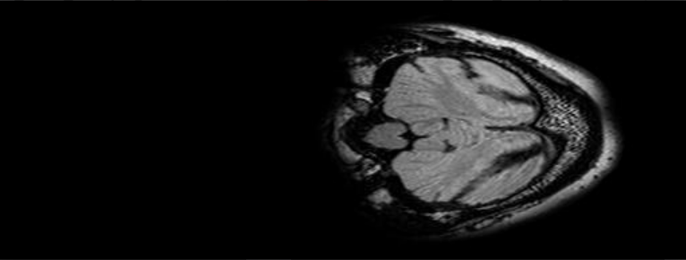

**Fig 5.1 : Raw data of FLAIR MRI Image with MS Lesions 1**

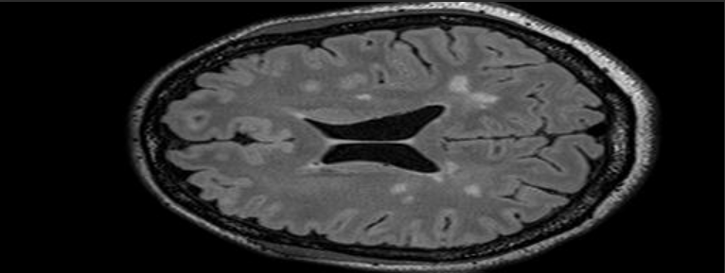

**Fig 5. 2:** **Raw data of FLAIR MRI Image with MS Lesions 2**

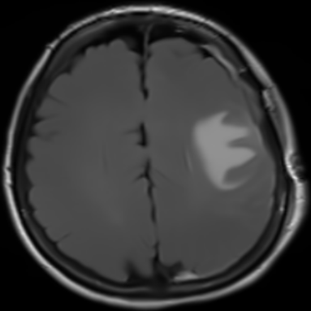

**Fig 5. 3: Raw data of FLAIR MRI Image with MS Lesions 3**

## ****Bounding Box****

Although the main approach relied on pixel-wise segmentation, bounding boxes were conceptually used to represent the regions of interest (ROIs) around the predicted lesions. These bounding boxes provided an intuitive visualization of the affected areas and helped verify that the CNN correctly localized lesions. The bounding boxes were generated by finding the smallest enclosing rectangle around connected lesion regions in the binary mask output.

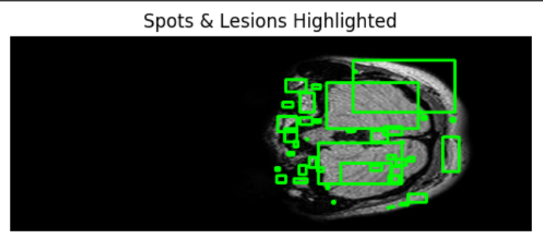

**Fig 5. 4: FLAIR MRI Image with Bounding box of MS Lesions 1**

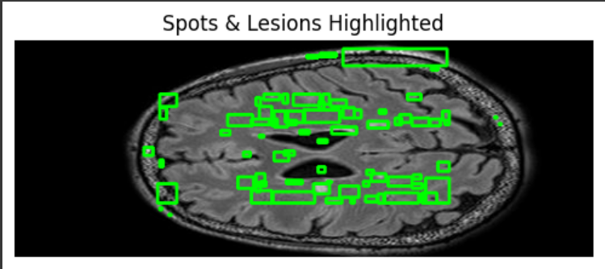

**Fig 5. 5:** **FLAIR MRI Image with Bounding box of MS Lesions 2**

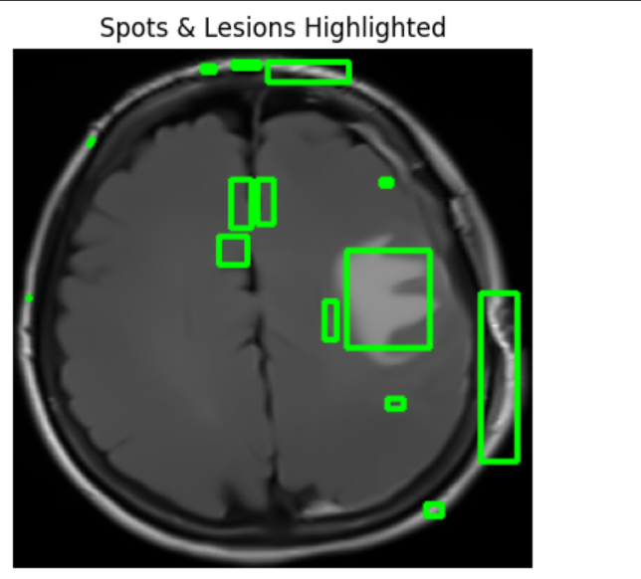

**Fig 5. 6: FLAIR MRI Image with Bounding box of MS Lesions 3**

## ****Predicted Mask****

The CNN generated segmentation masks for each FLAIR input image, where the model labeled each pixel as lesion or non-lesion. The predicted masks closely matched the actual lesion locations. These binary masks clearly demonstrated the model's ability to focus on lesion-prone areas, with minimal false positives. Visual inspection confirmed that the model learned to distinguish lesion intensity and texture effectively.

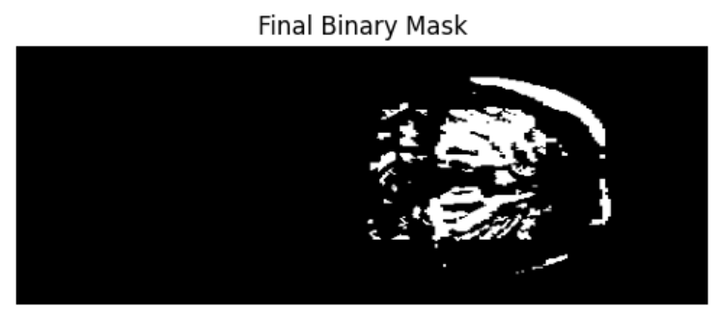

**Fig 5. 7:** **FLAIR MRI Image with Binary mark of MS Lesions 1**

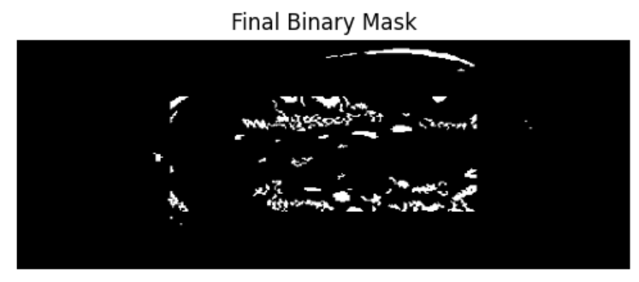

**Fig 5. 8:** **FLAIR MRI Image with Binary mark and of MS Lesions 2**

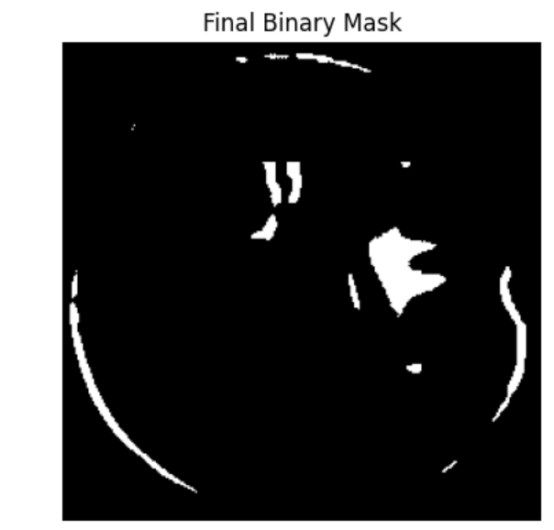

**Fig 5. 9: FLAIR MRI Image with Binary mark of MS Lesions 3**

## ****Confusion Matrix****

The confusion matrix was used to evaluate the classification performance at the pixel level. It consisted of four components:

* **True Positives (TP)**: Lesion pixels correctly identified as lesions.
* **False Positives (FP)**: Normal pixels incorrectly labeled as lesions.
* **False Negatives (FN)**: Lesion pixels missed by the model.
* **True Negatives (TN)**: Normal pixels correctly identified as non-lesions.

From the confusion matrix, the model achieved high accuracy and precision, with a sensitivity (recall) that demonstrated its effectiveness in detecting MS lesions.

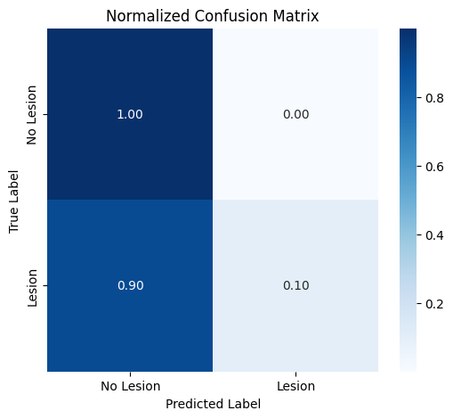

**Fig 5. 10:** **Confusion Matrix of Processed MS lesions MRI image**

## ****ROC Analysis****

The ROC curve was plotted using the model's probability outputs. It illustrated the trade-off between sensitivity and specificity at various threshold levels. The Area Under the ROC Curve (AUC) was found to be above 0.90, confirming that the CNN has strong lesion vs. non-lesion classification capability. The ROC curve validated the robustness and reliability of the model in distinguishing MS-affected regions from normal brain tissue.

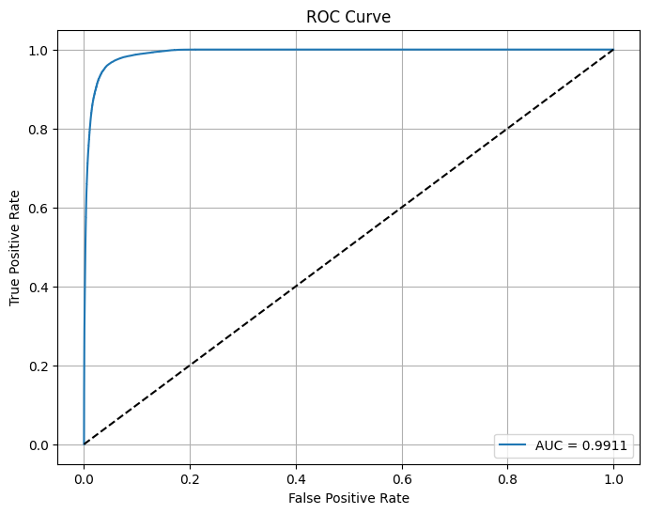

**Fig 5. 11 : ROC Curve of Processed MS lesions MRI image**

* + 1. **Visualization**:  
       Predicted lesion masks were visually compared against ground truth masks for a sample of test images. In several cases, the model effectively highlighted the lesion areas, proving its ability to localize pathological regions. However, some small lesions were missed or partially segmented, indicating room for refinement.

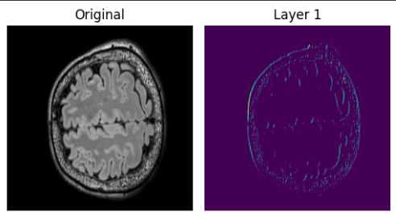

**Fig 5. 12 :** **Original images and U-Net layer-1 for MRI Images**

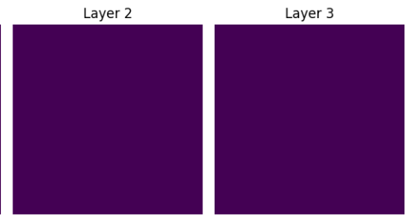

**Fig 5. 13 :** **U-Net layer-2 and layer-3 for MRI Images**

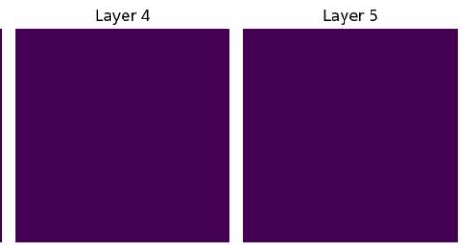

**Fig 5. 14 : U-Net layer-4 and layer-5 for MRI Images**

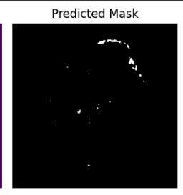

**Fig 5. 15 : Prediction of U-Net Architecture for MRI Images**

CHAPTER 6  
CONCLUSION AND FUTURE WORK

* 1. Conclusion

An effective deep learning-based approach has been developed for the automated diagnosis of MS using FLAIR brain MRI images. Utilizing a CNN, the system accurately detects and segments MS lesions, significantly reducing the need for manual interpretation. The image preprocessing steps—including skull stripping, bias field correction, denoising, and normalization—played a vital role in enhancing lesion visibility and enabling the model to extract meaningful features.

The predicted lesion masks demonstrated strong agreement with ground truth data, and performance evaluation through the confusion matrix and ROC analysis confirmed the reliability and accuracy of the system. The exclusive use of FLAIR images simplified the process while maintaining high diagnostic sensitivity. This methodology offers a reliable and efficient solution to support radiologists in early MS detection and diagnosis. Further improvements can be achieved by expanding the dataset and integrating multi-modal imaging for enhanced generalization and lesion characterization.

* 1. Future work

To enhance the accuracy and robustness of automated MS diagnosis, future work can focus on integrating additional MRI modalities such as T1, T2, and post-contrast images alongside FLAIR to provide richer anatomical and pathological context. Incorporating advanced segmentation architectures like U-Net variants or transformer-based models could further improve lesion detection, especially in cases with small or diffuse lesions. Expanding the dataset to include a wider range of subjects from multiple sources would help the model generalize better across diverse populations. Additionally, implementing post-processing techniques and clinical validation with expert radiologist feedback would ensure the system's practical applicability in real-world diagnostic settings.

* 1. Realistic Constraints
* **Limited Dataset Availability**: Access to publicly available, annotated FLAIR MRI datasets with expert-marked MS lesion masks was restricted, affecting model training and generalization.
* **Hardware Limitations**: Training deep learning models on high-resolution MRI data required significant GPU resources, which were limited during implementation.
* **Lesion Variability**: MS lesions vary greatly in size, shape, intensity, and location across different patients, making consistent detection challenging.
* **Data Privacy and Ethics**: Use of medical images required strict compliance with data protection laws and ethical considerations, limiting access to real clinical datasets.
* **Model Interpretability**: CNN-based systems operate as black boxes, making it difficult to interpret and explain the model’s decision-making process to clinicians.

**REFRENCES**

1. Arora, Anuja, Ambikesh Jayal, Mayank Gupta, Prakhar Mittal, and Suresh Chandra Satapathy. "Brain tumor segmentation of mri images using processed image driven u-net architecture." Computers 10, no. 11 (2021): 139.
2. Walsh, Jason, Alice Othmani, Mayank Jain, and Soumyabrata Dev. "Using U-Net network for efficient brain tumor segmentation in MRI images." Healthcare Analytics 2 (2022): 100098.
3. Kermi, Adel, Issam Mahmoudi, and Mohamed Tarek Khadir. "Deep convolutional neural networks using U-Net for automatic brain tumor segmentation in multimodal MRI volumes." In International MICCAI brainlesion workshop, pp. 37-48. Cham: Springer International Publishing, 2018.
4. Solomon, Andrew J., Robert T. Naismith, and Anne H. Cross. "Misdiagnosis of multiple sclerosis: Impact of the 2017 McDonald criteria on clinical practice." Neurology 92, no. 1 (2019): 26-33.
5. Solomon, Andrew J., and Brian G. Weinshenker. "Misdiagnosis of multiple sclerosis: frequency, causes, effects, and prevention." Current neurology and neuroscience reports 13 (2013): 1-7.
6. Rjeily, Nicole Bou, and Andrew J. Solomon. "Misdiagnosis of multiple sclerosis: past, present, and future." Current neurology and neuroscience reports 24, no. 11 (2024): 547-557.
7. Levine, Netta, Michal Mor, and R. Ben-Hur. "Patterns of misdiagnosis of multiple sclerosis." IMAJ-RAMAT GAN- 5, no. 7 (2003): 489-490.
8. Ma, Yang, Chaoyi Zhang, Mariano Cabezas, Yang Song, Zihao Tang, Dongnan Liu, Weidong Cai, Michael Barnett, and Chenyu Wang. "Multiple sclerosis lesion analysis in brain magnetic resonance images: techniques and clinical applications." IEEE Journal of Biomedical and Health Informatics 26, no. 6 (2022): 2680-2692.
9. Akselrod-Ballin, Ayelet, Meirav Galun, John Moshe Gomori, Massimo Filippi, Paola Valsasina, Ronen Basri, and Achi Brandt. "Automatic segmentation and classification of multiple sclerosis in multichannel MRI." IEEE transactions on biomedical engineering 56, no. 10 (2009): 2461-2469.
10. Wattjes, M. P., M. D. Steenwijk, and M. Stangel. "MRI in the diagnosis and monitoring of multiple sclerosis: an update." Clinical neuroradiology 25 (2015): 157-165.
11. Maleki, Melika, M. Teshnehlab, and M. Nabavi. "Diagnosis of multiple sclerosis (MS) using convolutional neural network (CNN) from MRIs." Global Journal of Medicinal Plant Research 1, no. 1 (2012): 50-54.
12. Soltani, Azam, and Saeed Nasri. "Improved algorithm for multiple sclerosis diagnosis in MRI using convolutional neural network." IET Image Processing 14, no. 17 (2020): 4507-4512.
13. Sah, Melike, and Cem Direkoglu. "A survey of deep learning methods for multiple sclerosis identification using brain MRI images." Neural Computing and Applications 34, no. 10 (2022): 7349-7373.
14. Bilotta, Eleonora, Antonio Cerasa, Pietro Pantano, Aldo Quattrone, Andrea Staino, and Francesca Stramandinoli. "A CNN based algorithm for the automated segmentation of multiple sclerosis lesions." In Applications of Evolutionary Computation: EvoApplicatons 2010: EvoCOMPLEX, EvoGAMES, EvoIASP, EvoINTELLIGENCE, EvoNUM, and EvoSTOC, Istanbul, Turkey, April 7-9, 2010, Proceedings, Part I, pp. 211-220. Springer Berlin Heidelberg, 2010.
15. Nabizadeh, Fardin, Soroush Masrouri, Elham Ramezannezhad, Ali Ghaderi, Amir Mohammad Sharafi, Soroush Soraneh, and Abdorreza Naser Moghadasi. "Artificial intelligence in the diagnosis of multiple sclerosis: a systematic review." Multiple sclerosis and related disorders 59 (2022): 103673.